Figure: 1969 – 2010 Average annual % change in productivity vs average annual percent point change in union share…

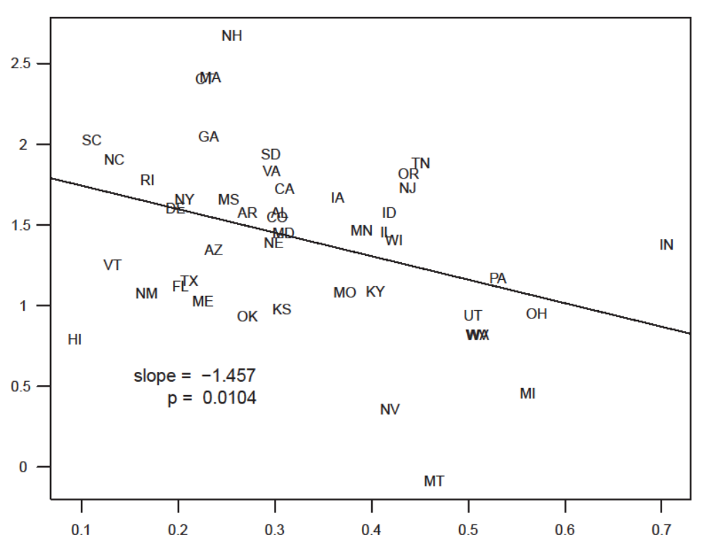

Notes:
Sources:

Figure: 1969 – 2010 Average annual % change in productivity vs average annual percent point change in manuf share…

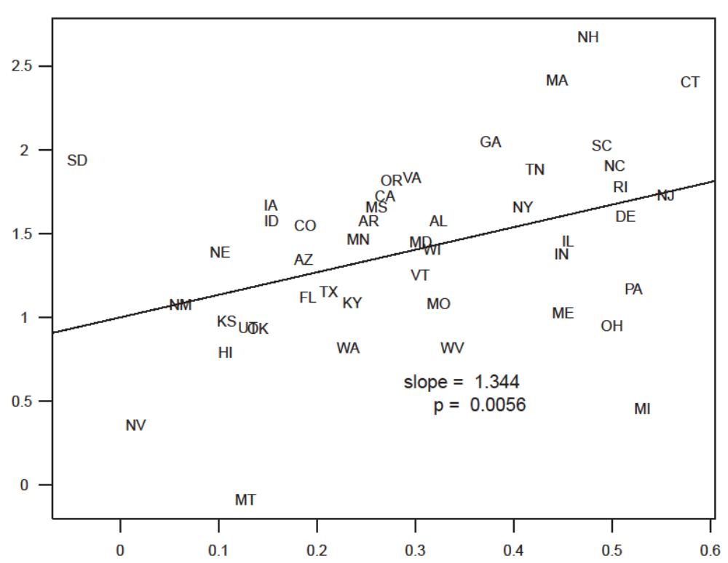

Figure: 1969 – 1984…union…

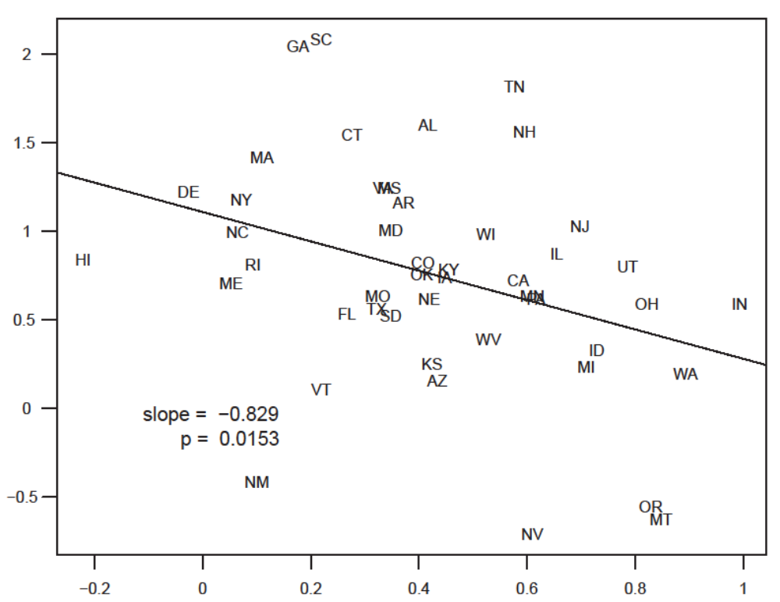Notes:
Sources:

Figure: 1969 – 1984…manuf…

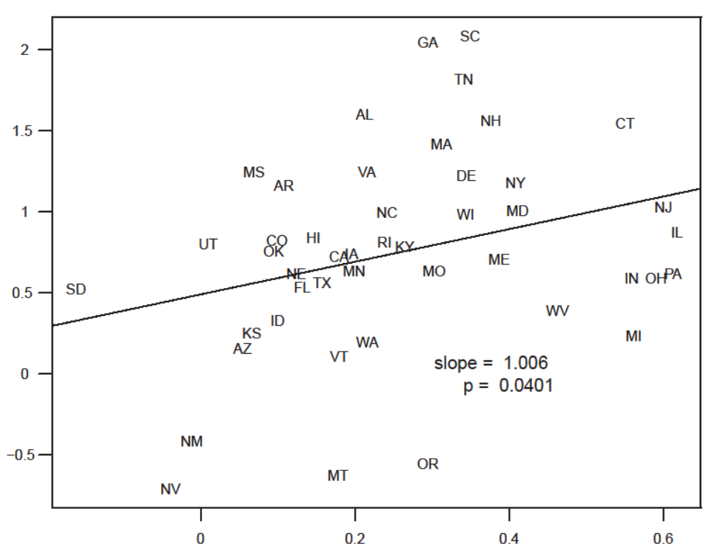
Notes:
Sources:

Figure: 1985 – 2010…union…
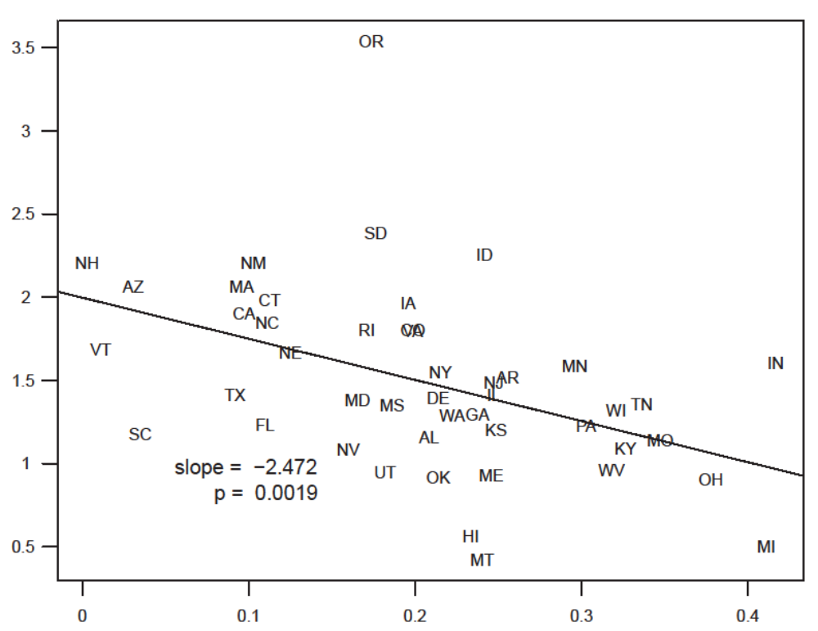

Notes:
Sources:
Figure: 1985 – 2010…manuf…

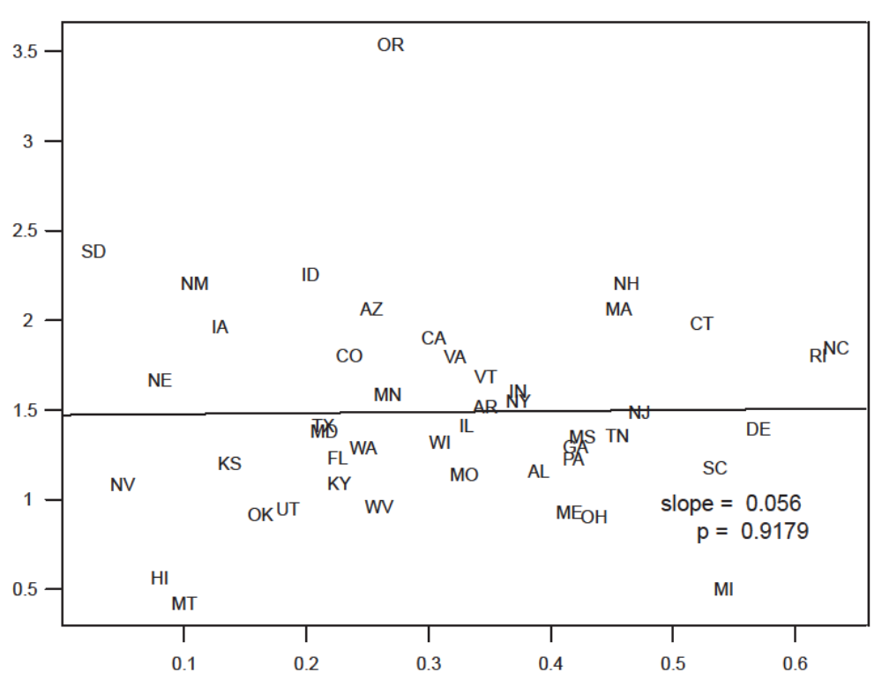
Notes:
Sources:

Comparison of regression lines by period:

